Computer Programming Lab – 2

1. Write a program to print if number is divisible by 3 or 5 or both. Input should be given by user.

#include <stdio.h>

int main()

{

int num;

printf("Enter the number: ");

scanf("%d", &num);

if (num%3 == 0 && num%5 ==0)

printf("The number %d is divisible by both 3 and 5", num);

else if (num%3 == 0)

printf("The number %d is divisible by 3", num);

else if (num%5 == 0)

printf("The number %d is divisible by 5", num);

else

printf("The number %d is neither divisible by 3 nor 5", num);

return 0;

}

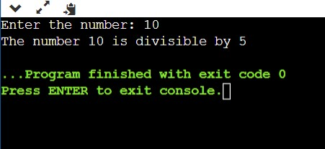

2. Write a program to print to find largest of three given numbers. Input should be given by user.

#include <stdio.h>

int main()

{

int num1, num2, num3;

printf("Enter the first number: ");

scanf("%d", &num1);

printf("Enter the second number: ");

scanf("%d", &num2);

printf("Enter the third number: ");

scanf("%d", &num3);

if (num1>num2 && num1>num3)

printf("The number %d is the largest among the entered three numbers", num1);

else if (num2>num1 && num2>num3)

printf("The number %d is the largest among the entered three numbers", num2);

else

printf("The number %d is the largest among the entered three numbers", num3);

return 0;

}

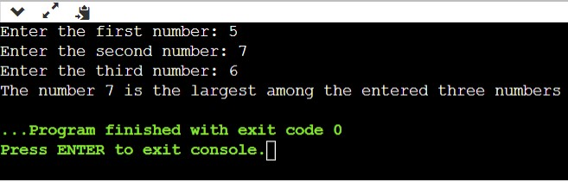

3. Write a program to find factorial of a number.

#include <stdio.h>

int main()

{

int num, i, fact=1;

printf("Enter the number: ");

scanf("%d", &num);

for (i=1; i<=num; i++)

{

fact = fact\*i;

}

printf("The factorial of the number %d is %d", num, fact);

return 0;

}

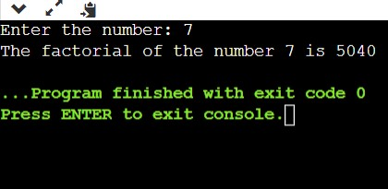

4. Write a program to check if a number is prime or not.

#include <stdio.h>

int main()

{

int num, i, c=0;

printf("Enter the number: ");

scanf("%d", &num);

if (num >=1)

for (i=2; i<=num; i++)

{

if (num%i == 0)

{

printf("The entered number is not prime");

c=1;

break;

}

}

if (c == 0)

printf("The entered number is prime");

return 0;

}

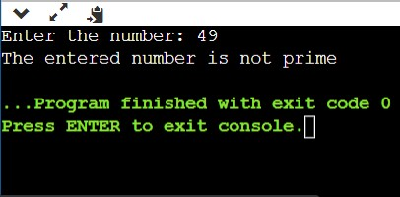

5. Write a C program to input electricity unit charges and calculate total electricity bill according to the given condition: For first 50 units Rs. 0.50/unit For next 100 units Rs. 0.75/unit For next 100 units Rs. 1.20/unit For unit above 250 Rs. 1.50/unit An additional surcharge of 20% is added to the bill. Take number of units from user

#include <stdio.h>

int main()

{

int unit;

float bill, cost;

printf("Enter the electricity unit charges: ");

scanf("%d", &unit);

if (unit<=50)

{

bill = unit\*0.50;

cost = bill + (bill\*0.2);

printf("The total electricity bill is %f\n", cost);

}

else if (unit>50 && unit<=150)

{

bill = (50\*0.5)+ ((unit-50)\*0.75);

cost = bill + (bill\*0.2);

printf("The total electricity bill is %f\n", cost);

}

else if (unit>150 && unit<=250)

{

bill = (50\*0.5)+ (100\*0.75)+ ((unit-150)\*1.20);

cost = bill + (bill\*0.2);

printf("The total electricity bill is %f\n", cost);

}

else if (unit>250)

{

bill = (50\*0.5)+ (100\*0.75)+ (100\*1.2)+ ((unit-250)\*1.50);

cost = bill + (bill\*0.2);

printf("The total electricity bill is %f\n", cost);

}

return 0;

}

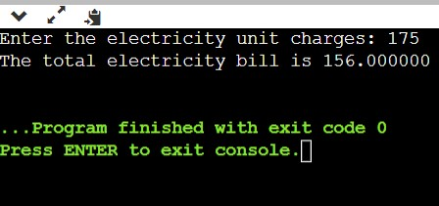

6. Write a program to check whether a triangle is valid. If valid, find if it is isosceles, equilateral, or scalene.

#include <stdio.h>

int main()

{

int num, i, c=0;

printf("Enter the number: ");

scanf("%d", &num);

if (num >=1)

{

for (i=2; i<num; i++)

{

if (num%i == 0)

{

c=1;

break;

}

}

}

if (c == 0)

printf("The entered number is prime");

else

printf("The entered number is not prime");

return 0;

}

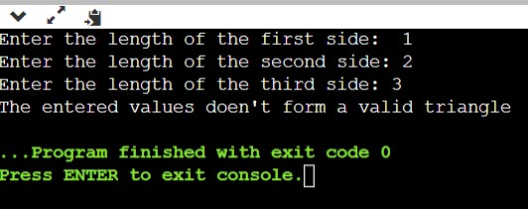

7. Write a program to find whether a given year is leap or not. Year is provided by user. NOTE: A year is leap if it is divisible by 4 and not divisible by 100. A year is also leap if it is divisible by 400.

#include <stdio.h>

int main()

{

int year;

printf("Enter the year: ");

scanf("%d", &year);

if (year%400 == 0)

{

printf("It's a Leap year");

}

else if (year%4 == 0 && year%100 != 0)

{

printf("It's a Leap year");

}

else

{

printf("It's not a Leap year");

}

return 0;

}

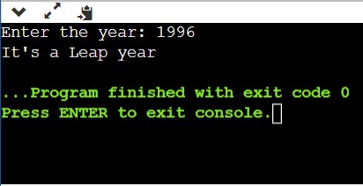

Write program to print following patterns.

8.

1

12

123

1234

12345

#include<stdio.h>

int main()

{

int i, j;

for (i=1; i<=5; i++)

{

for (j=1; j<=i; j++)

{

printf("%d", j);

}

printf("\n");

}

return 0;

}

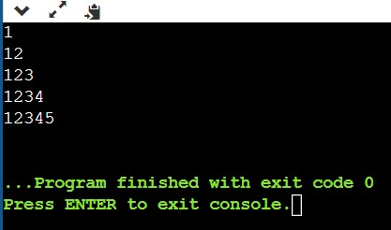

9.

\*

\*\*\*

\*\*\*\*\*

\*\*\*

\*

#include <stdio.h>

int main()

{

int i,j;

for(i=1; i<=5; i++)

{

for(j=1; j<=5; j++)

{

if(i == 3 || j == 3)

printf("\*");

else if ((i == 2 || i == 4) && (j == 4 || j == 2))

printf("\*");

else

printf(" ");

}

printf("\n");

}

return 0;

}

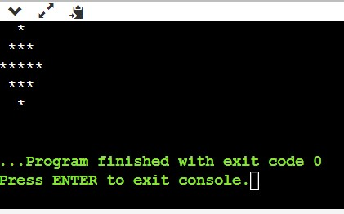

10.

#include <stdio.h>

int main()

{

int i,j,a;

for(i=1; i<=9; i++){

a = i;

if (i>5)

a = 10-i;

for (j=1; j<=9; j++){

if (i == j)

printf("%d", a);

else if (i+j == 10)

printf("%d", a);

else

printf(" ");

}

printf("\n");

}

return 0;

}

